**Experiment 3**

Guneet Singh Sura

16010420075

Batch: A3

**Code to perform file operations:**

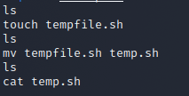

**Output:**



**Code to parse the date:**



**Output:**



**Code to read and ping IP:**

Create the first file (say ip.sh) and enter the code below

ifconfig -a | grep inet | grep -v '127.0.0.1' | awk '{ print $2}'

Create a second file then enter this code

./ip.sh > address.txt

#!/bin/sh

awk '{print $1}' < address.txt | while read ip;

do

if ping -c1 $ip>/dev/null 2>&1; then

echo $ip IS UP

else

echo $ip IS DOWN

fi

done

**Output:**

